

**UNIVERSITY OF KENT**

**KENT BUSINESS SCHOOL**

**2022/2023**

|  |  |
| --- | --- |
| Student name: | Akshitha Rao |
| Login: | ar798 |
| Student declaration: | I confirm that: This is an original assessment and is entirely my own work. Where I have used ideas, tables, figures of other authors, I have acknowledged the source in every case. This assignment was not submitted previously as assessed work for any other academic course. |
| Student’s signature: | |
| Date of signature:  Title:  Word count: | 2,344 (within the allowance of 10% deviation) |

**Module: Operations Management and Digital Transformation (BUSN9320)**



Digitalization of Agriculture

Table of Contents

1. Executive Summary ............................................................................................................................. 3

2. Introduction ......................................................................................................................................... 4

3. Digitalisation of Agriculture ................................................................................................................. 5

3.1 5 Performance Objectives...................................................................................................................5

3.2 4Vs’ at Bayer ......................................................................................................................... ……. ……6

3.3 The Transformation Process .............................................................................................................. 6

3.4 Impact on Supply Chain................................... ……………………………………………………………………………….7

3.5 Internet of Things and Big Data Influence ……... ……………………………………………………………………………. 7

4. Summary of Key Observations .......................................................................................................... ...9

5. References ........................................................................................................................................... 10

1. Executive Summary

Agriculture is considered as a foundation to a prospering economy. However, in recent years we see growing factors like climate change, conflict, decrease in yield productivity pose a threat to practice of agriculture efficiently. Adding to this, the increase in population is the primary challenge facing this industry along with decline in the availability of fertile land. Food and Agricultural Organization has reported that the world population will increase to 9.73 billion by 2050 and will continue to accelerate till 2100. (https://www.sciencedirect.com, 2021).

This is directly proportional to increase in food production. The need of the hour is to adopt ways of attaining an equilibrium between growing population, demand in food produce vs declining resources. Since ages, farmers have been relying on traditional data collection methods to maintain this balance and meet the growing demands of society while encountering mounting hurdles like deteriorating soil health, reduction in acres of arable land, water table depletion, growing costs, pests and environmental hazards. This paved way to introduction of technical expertise to help alleviate these pressing challenges in the sector. Organizations understood the magnitude of this issue along with-it opportunity for revenue generation by introducing smarter technologies that led to

“Sustainable agriculture through smart farming methods enabled by technical expertise and agronomics knowledge targeting dependable revenue generation” *(Refer to Figure 1)*

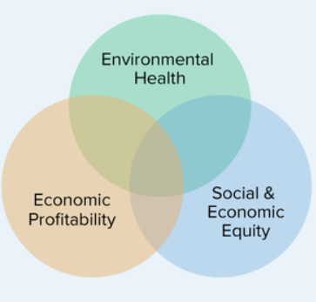Bayer is one such organization which revolutionised the agricultural industry with technical acumen and experience. Introduced novel methods using IoT, AI, Big Data to identify and eradicate issues faced by farmers and build solutions that assist them in meeting the critical demands in terms of increasing yield, prevention of diseases, monitoring soil and crop health, predicting weather patterns, reducing operational cost and agricultural inputs and achieving optimal use of resources.

Concepts like precision agriculture, genetically modified seeds, unmanned robots and drones that study, map, and analyse the farmland specifics, cloud technology and user-friendly digital tools played a huge role in identifying and delivering customized solutions.

As in every field, there are challenges that need to be mitigated resulting in research and development to continuously strive forward with undeterred focus on new inventions and solutions to meet the evolving demands of the farmers, society, government regulations and at the same time managing ecological balance.

Figure : Visual representation of "Sustainable Agriculture". Source: https://sarep.ucdavis.edu/sustainable-ag

The struggle for excellence is constantly driven by the below objective:

#### “The goal of sustainable agriculture is to meet society’s food and textile needs in the present without compromising the ability of future generations to meet their own needs.” (Program., 2021)

2. Introduction

“Bayer: Science for A Better Life” - Bayer’s (Bayer, 2022) mission reflects the values the organization carries in developing solutions which works towards a better society through sustainable and responsible ways. As a way forward towards this agenda, Bayer delivers holistic solutions to enable digitalization of agriculture. Their initiatives work as a collaboration between technical expertise and agronomic knowledge promoting digitally connected farms through smart farming. Smart farming as a market is predicted with a market revenue of USD 7.04 billion by 2026. (Technavio, 2022).

Smart Farming involves elements like

1. IoT devices to manage soil fertility, pollutions levels in water and environment.
2. Cellular connectivity to effectively transmit data across the digitally connected environment.
3. Navigation devices powered by GPS to reduced manual intervention
4. Agricultural drones and robots to automate and improve the processes involved in farming thus increasing the success rate of the crop.
5. Cloud based tools and AI to store, analyse and visualize datasets for better management of inputs and deliver

Meaningful insights.

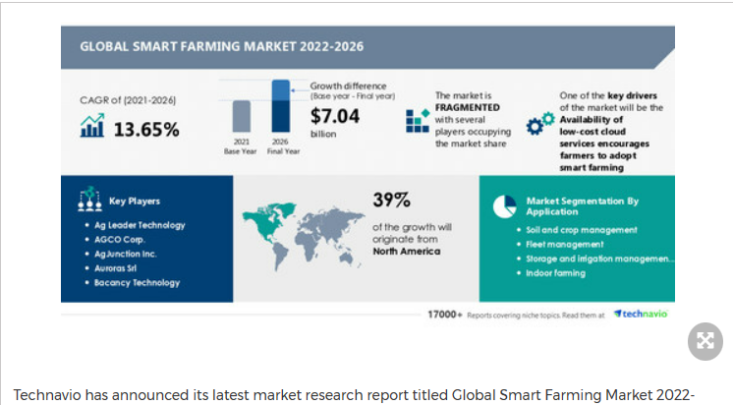Bayer is a pioneer enabling smart farming through digital transformation across farmlands due to their domain expertise & innovation technologies and estimate $ 500 billion in GDP (2030) could be achieved by interconnecting farmlands digitally. (Bayer, 2022). They are leading this revolution in agriculture through

**ForwardFarming** - knowledge platform powered by digital tools to foster dialogues among independent stakeholders, value chain partners, academia and scientists to work towards the common goal of “Health for all, Hunger for none” (Bayer, 2022)

**Climate FieldView** - FieldView collects and combines public data values such as weather conditions, climate patterns along with farmers’ prior farm yield performance and historical data in one place to derive well informed and efficient decisions.

Figure : Market research published by technavio. Source: www.prnewswire.com

**FarmRise Mobile Farm Care** - It is a mobile app to share best practices, agronomic advice amongst small scale farmers in India. They receive location specific details to support data driven crop protection methods.

It’s been an age-old practice where data points like soil fertility, rainfall, seed variety, quality and climate etc were utilized in farming, however in today’s world the need to optimize more for less, motivated farmers to use sophisticated tools from advanced weather monitoring to satellite remote sensors. Bayer’s digital transformation strategy in agriculture sector rebuilds traditional practices into integrated technical expertise and real time data generation targeting precision to analyse, manage and protect crop yield.

3. Digitalisation of Agriculture

As a continuation to the “Introduction”, we are now going to be analysing how the digital transformation is applied as a strategy to Bayer’s operations:

3.1 The 5 Performance Objectives (PO’s):

This section discusses about the impact of 5 POs on Bayer.

1. Quality

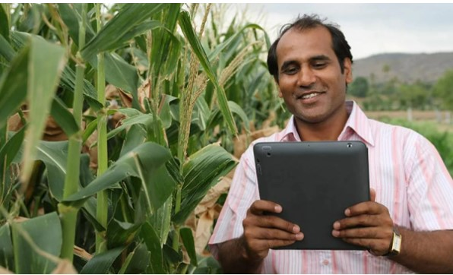In agriculture, producing quality products with least disruption to environment is always a challenge. Bayer supports farmers in cultivating eco-friendly produce and improve their harvest quality through technical revolution. Crop protection and providing accurate information at right time plays an important role in this process and Bayer’s FarmRise Mobile Farm Care. *(Refer to Figure 3)* which is in use in India, contributes to crop yield protection against pests & diseases and also shares precise information on farming methods. Approximately 70% of smallhold farmers are benefitted by this pilot project and it might be a reference for its replication across globe.

Figure 3: A farmer in India monitoring his crop through FarmRise. Source: https://www.bayer.com

1. Speed

It’s not just the access to digital tools but the time and speed at which farmers are able to harness the insights gained through these tools plays a pivotal role in addressing ever evolving challenges in farming. The environment of digital applications at Bayer like drones, remote sensors, satellite imagery constant collect thousands of data points from the fields while AI algorithms simultaneously process and transfer them back to farmers to take time-bound and critical decisions. One such example is Bayer’s digital platform Climate FieldView that enables farmers to access data from systems that are incorporated in their fields and also refer historical information like weather patterns, pests’ infestation, seasonal diseases, droughts etc with reference to specific regions and geographical locations stored in servers. This helps in timely response to the issues faced ensuring optimal use of resources at reduced cost.

1. Dependability

Growing global partnerships and increasing positive impact on modern agriculture through Bayer’s deployment of digitalisation speaks for its reliability from clients. Being transparent promotes the customer & stakeholder’s confidence and they are first company in this industry to make their data public with regards to crop protection and genetically transformed seeds.

1. Flexibility

As per Bayer’s guiding principle they aim to be flexible through digitalisation and application of data science. Their R&D strives to enhance their systems to adapt to the evolving needs of farmers.

1. Cost

Bayer revenue generation is through per acre fee for its services and digital platform subscriptions. They have also introduced a concept “outcome-based pricing model” (Gullickson, 2019) (Nuelle, 2020) for corn cultivation in US wherein a yield guarantee is provided to farmers and if its met, profit is shared 50-50 and if not, Bayer will compensate the farmer for the difference. In spite of its bottlenecks like data privacy, digital management of inputs from farmers, transparency it’s still being considered by beginners in industry. Also, the digital tools deployed by Bayer’s to farmers is likely to reduce the farming costs and thus increasing the profit margins for the farmers and also the organization.

3.2 The 4V’s at Bayer:

A visual representation of 4Vs’ at Bayer is illustrated below.

3.3 The Transformation Process:

The performance objectives work as a fulcrum to drive digital transformation process at Bayer which aims at staying interconnected amongst the various digital components and guides towards data driven decisions.

This process is as below:

1. Input – Data gathered through different sources, like field sensors, field robots, satellite capture, farmers traditional ways of agriculture, historical data are all collected and combined.
2. Transformation – The individual data sets are stored, interconnected, cleansed, analysed to form meaningful insights through AI algorithms. These are then used to form varied charts, patterns, forecasting graphs, and other vital insights which can be stored and used for current and future needs.
3. Output – The wealth of information obtained from the above process is fed into different digital tools used by farmers like FieldView etc. This provides 24/7 accessible information to them at their fingertips in terms of visualizations, reports, weather patterns, pest control information, soil & seed quality, crop health & harvest.

Illustrated below is a visual representation of the above process:

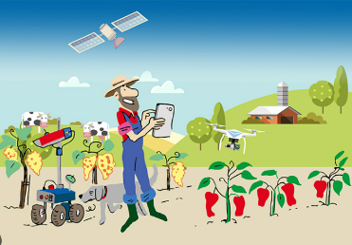

Digitally empowered farmer taking informed decisions

Figure 4: European Union. Source: www.cordis.europa.eu

3.4 Impact on Supply Chain:

Bayer manages over 600,000 hectares of farmlands as part of its smart farming and sustainable agriculture initiatives which clearly represents its operations magnitude. *(Dirk Backhaus, head of product supply at Bayer A explains supply chain model in a podcast available at www.gartner.com)*

Agriculture sector is characterised by a seasonal supply chain for which planning is key. Seeds needed for next season are produced the previous season and pre-planning for this starts much earlier. This is achieved by predicting weather patterns and soil fertility in advance using historical data and forecasting methods with the help of IoT, remote sensors, drones and artificial intelligence.

Digital technologies like SeedAdvisor, real time data visualisation using satellite imagery predicts yield data and analyses the data for optimal production in the following season. The aforementioned process requires separate production unit and then they are all virtually connected at warehouse, distribution channels and retail and eventually the next stage is to have the genetically modified seeds or customized digital tools reach the grower as per their requirements. This involves careful analysis of insights received from farmers across their network through various digital tools deployed to them like FarmRise and FarmView.

They work with AI to try robust sustainable solutions and connect the entire farming ecosystem and transform them faster. Bayer and Microsoft joined hands to offer a B2B solution as part of Bayer’s strategy to accomplish 100% digitally empowered sales in their CropScience division by 2030. This collaboration is to develop solutions for sustainable procurement and supply chain enhancements. (https://www.futurefarming.com/smart-farming, 2021)

Physical Logistics comes to play in movement of seeds or fertilizers and digital tracking of delivery trucks ensures on time supply of products.

Bayer now invests in selling digitally enabled solutions which is possible through digital transformation to achieve the above rather than individual products. *Figure 5* illustrates the connectivity between the different stakeholders of their supply chain environment. They utilize marketplaces, e-commerce, 360-degree view of customer experience and physical logistics to establish a digitally enabled supply chain operation.

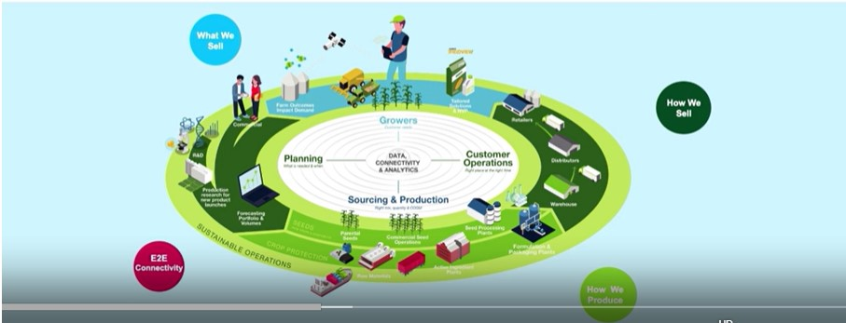

Figure 5: Visual representation of Bayer's supply chain model. Source: [www.gartner.com](http://www.gartner.com)

3.5 Internet of Things & Big Data’s influence:

The agriculture as an industry is witnessing alarming changes as we discussed earlier in this report due to various factors like growing population, environmental degrade etc. This motivates Bayer and several other key players in this field to seize the opportunity to develop integrated digital tools and solutions as a resolution. Though use of technology was prevalent for few years, organizations are now frantic to expand their digital capabilities and are focusing on building a sustainable and affordable future in agriculture and at the same time guarantee revenue generation for farmers by reducing operational costs. Smart Combines is such an innovative method which converges various data points and synchronize them across digital tools

Big Data and IoT plays an important role in this process through sensors, AI powered robots, drones, predictive and precision agriculture. Bayer accomplishes smart farming stages like planting, fighting against pests and diseases, monitoring crop growth and health, harvest and a knowledge repository combining Big Data, AI and IoT.

1. Planting – Drones and self-driving precision planters and tractors (Bayer, n.d.) enable precise sowing of seeds at the accurate depth and distance from each other increasing their rate of success.
2. Fight against pests – Unique sprayers help identify the weeds and pests and section of fields which require remediation rather than surrounding areas thus reducing the usage of pesticides and produce quality crop.
3. Monitoring – In-field sensors (Bayer, n.d.)and satellites help track soil fertility, crop growth, nutrient deficiencies, climate forecast to provide timely & accurate updates to farmers and allow them to be more agile.
4. Harvest – Solutions are under continuous development and goal is to eliminate strenuous manual labour. It’s uses are estimated to grow multifold and by 2030 will play a vital role in agriculture (Bayer, n.d.). For e.g.: pepper pickers, a prototype which is now in practice.
5. Knowledge Repository – The data generated is stored as patterns and visualisations to be used during next cycles as a reference guides.

Bayer in collaboration with Google cloud and its platform FieldView uses machine learning and AI to collect, process, analyse massive amounts of data generated through above processes and has it streamlined, processed and stored efficiently in order to be transformed to meaningful data points that facilitate agriculturists to take informed actions.

4. Summary

Bayer’s digital transformation strategy started way back in 2016 when they incorporated “let’s build digital to our DNA” (Federer, 2016). Their aim was to incorporate this strategy into mainstream business so much that this becomes their way forward in future business models.

Their vision is to have end to end connectivity backwards in terms of growers to distribution channels to manufacturing of seeds and ideally to suppliers. Though this project involves huge investments, this is achievable through digital capabilities in near future.

They are in a constant endeavour to invest in their R&D resulting in development of new digital farming solutions to meet future challenges related to growing uncertainties in environment, sustainability and regulations.

Though they are well positioned now to be called as leader in this market segment, we observe there are few challenges as outlined below due to automation and digitalization of this industry.

* Over dependence on technology and expenses of adapting this technology in farms proves as a challenge in developing countries
* Accountability in the event of misinterpretation of technical data and failures.
* There might be unemployment issues for traditional farmers and support workers who are not tech-savvy. Increasing and additional costs incurred while imparting knowledge to transform existing resources or recruiting technically sound people to manage farms.
* Price for the end user might increase in due course as organizations and farmers will need to find an avenue to absorb the additional expenses.
* Non-existence of regulatory framework governing the data transfer and proprietary issues in this market.

In spite of all hurdles and challenges, this market is set to expand to cater to massive increase in food generation targets with limited resources and target sustainable environment. More innovations like vertical farming, agricultural robots. Every aspect of smart farming needs continuous monitoring and technological advancements in order for the world to meet the demands of the future. *(Refer to Figure 6)*. To conclude, Bayer will remain as an industry leader and is and will be committed to drive the momentum towards sustainable agriculture.

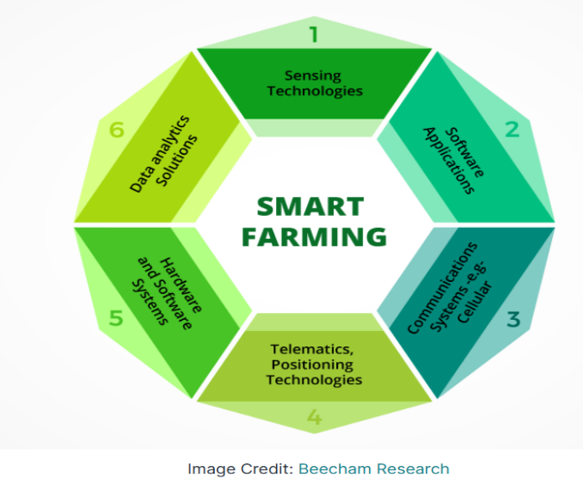

Figure 6: Illustration of Smart Farming components. Source: [Smart Farming: The Future of Agriculture (iotforall.com)](https://www.iotforall.com/smart-farming-future-of-agriculture)

References:

1.  [Our Mission - Crop Science India (bayer.in)](https://www.cropscience.bayer.in/Company-V/Mission-and-Values#:~:text=Our%20Bayer%20Group%20mission%20%E2%80%9CBayer%3A%20Science%20For%20A,high-quality%20food%2C%20feed%2C%20fiber%20and%20renewable%20raw%20materials.) – (Accessed on 22nd December 2022)

2. [About Bayer Crop Science UK - (Accessed on 22](https://cropscience.bayer.co.uk/about-us/)[nd](https://cropscience.bayer.co.uk/about-us/) [December 2022)](https://cropscience.bayer.co.uk/about-us/)

3. [Forward Farming Initiative | Bayer global](https://www.bayer.com/en/agriculture/forwardfarming) - (Accessed on 22nd December 2022)

4.Bayer U.S. 🇺🇸 | Crop Science on Twitter: "What does a #modernfarm look like? It’s a combination of innovative and sustainable practices that improve the quality of our food while taking care of the environment. https://t.co/fbpXSGM4Ef" / Twitter - (Accessed on 22nd December 2022)

5.[Digital Farming for Crop Protection | Bayer global](https://www.bayer.com/en/agriculture/digital-farming-technology-world) - (Accessed on 22nd December 2022)

6.[Bayer launches sustainable agriculture hub to connect U.S. farmers, food and fuel makers | Reuters](https://www.reuters.com/business/sustainable-business/bayer-launches-sustainable-ag-hub-connect-us-farmers-food-fuel-makers-2022-08-15/) - (Accessed on 22nd December 2022)

7.[Field View (bayer.co.uk) - (Accessed on 22](https://cropscience.bayer.co.uk/fieldview/)[nd](https://cropscience.bayer.co.uk/fieldview/) [December 2022)](https://cropscience.bayer.co.uk/fieldview/)

8.[Our Agriculture Innovation Pipeline | Bayer global](https://www.bayer.com/en/agriculture/pipeline) - (Accessed on 24th December 2022)

9. (Torres, 2019) ,[Promise, challenges of outcomes-based pricing (farmprogress.com)](https://www.farmprogress.com/technology/promise-challenges-outcome-based-pricing)- - (Accessed on 24th December 2022)

10. [Our Brand. Our Values. | Bayer global](https://www.bayer.com/en/commitments/our-values) - (Accessed on 24th December 2022)

11. [Bayer launches sustainable agriculture hub to connect U.S. farmers, food and fuel makers | Reuters](https://www.reuters.com/business/sustainable-business/bayer-launches-sustainable-ag-hub-connect-us-farmers-food-fuel-makers-2022-08-15/)

12. [The Strategy of Bayer | Bayer global](https://www.bayer.com/en/strategy/strategy) - (Accessed on 25th December 2022)

13. (Dirk Backhaus ,2020), [Supply Chain Sustainable Agriculture: A View From Bayer's Supply Chain (gartner.com)](https://www.gartner.com/en/supply-chain/trends/supply-chain-strategies-for-sustainable-agriculture) - (Accessed on 25th December 2022)

14. (Nuelle, 2020) [Outcome-based pricing aims to reduce farmers financial risk | 2020-01-02 | Agri-Pulse Communications, Inc.](https://www.agri-pulse.com/articles/12994-outcome-based-pricing-aims-to-reduce-farmers-financial-risk) -(Accessed on 25th December 2022)

15. [Bayer Moves Ahead With Outcome-Based Pricing Model | Successful Farming (agriculture.com)](https://www.agriculture.com/news/business/bayer-moves-ahead-with-outcome-based-pricing-model) - (Accessed on 25th December 2022)

16. [Bayer and Microsoft partner to develop digital farming tools - Future Farming -](https://www.futurefarming.com/smart-farming/bayer-and-microsoft-partner-to-develop-digital-farming-tools/) (Accessed on 25th December 2022)

17.[Our Mission - Crop Science India (bayer.in)](https://www.cropscience.bayer.in/Company-V/Mission-and-Values#:~:text=Our%20Bayer%20Group%20mission%20%E2%80%9CBayer%3A%20Science%20For%20A,high-quality%20food%2C%20feed%2C%20fiber%20and%20renewable%20raw%20materials.) - (Accessed on 25th December 2022)

18. [About Bayer Crop Science UK](https://cropscience.bayer.co.uk/about-us/) - (Accessed on 25th December 2022)

19. [How Bayer transformed its approach to digital - PMLiVE](https://www.pmlive.com/pharma_thought_leadership/how_bayer_transformed_its_approach_to_digital_899002) - (Accessed on 25th December 2022)

[20. Precision Farming: Sowing the seeds of a new agricultural revolution | Results Pack | CORDIS | European Commission (europa.eu)](https://cordis.europa.eu/article/id/400295-precision-farming-sowing-the-seeds-of-a-new-agricultural-revolution) - (Accessed on 29th December 2022)

21. [Bayer launches new agri-tech app for faster decision making in the field | Manchester Digital](https://www.manchesterdigital.com/post/code-computerlove/agri-techapp) -(Accessed on 29th December 2022)

22.[Smart Farm Sensing – Smart farm sensing](https://www.smartfarmsensing.com/) - (Accessed on 29th December 2022)

23.[Smart Farming Technologies | Bayer global](https://www.bayer.com/en/agriculture/article/smart-farming-technology-automated-agriculture)- (Accessed on 29th December 2022)

24. [Bayer Crop Science: Unlocking value through AI-driven digital farming - Digital Innovation and Transformation (harvard.edu)](https://d3.harvard.edu/platform-digit/submission/bayer-crop-science-unlocking-value-through-ai-driven-digital-farming/#_ftnref4)- (Accessed on 29th December 2022)- - (Accessed on 14th January 2022)

25.[How Digital Farming Nurtures a Data Ecosystem | Bayer global](https://www.bayer.com/en/agriculture/article/ecosystem-ecosystem)-(Accessed on 29th December 2022)

26. [Smart farming market to grow by USD 7.04 Billion by 2026, Availability of low-cost cloud services that encourages farmers to adopt smart farming to boost market growth - Technavio (prnewswire.com)](https://www.prnewswire.com/news-releases/smart-farming-market-to-grow-by-usd-7-04-billion-by-2026--availability-of-low-cost-cloud-services-that-encourages-farmers-to-adopt-smart-farming-to-boost-market-growth---technavio-301680264.html) - (Accessed on 31st December 2022).

27. [The Strategy of Bayer | Bayer global](https://www.bayer.com/en/strategy/strategy) – (Accessed on 31st December 2022)

28. UC Sustainable Agriculture Research and Education Program. 2021. "What is Sustainable Agriculture?" UC Agriculture and Natural Resources. [What is Sustainable Agriculture? | Sustainable Agriculture Research & Education Program (ucdavis.edu)](https://sarep.ucdavis.edu/sustainable-ag)- (Accessed on 31st December 2022)

29. (Achim Walter achim.walter@usys.ethz.ch, 2017)[Smart farming is key to developing sustainable agriculture | PNAS](https://www.pnas.org/doi/10.1073/pnas.1707462114#:~:text=Smart%20farming%20can%20make%20agriculture%20more%20profitable%20for,reliability%20of%20spatially%20explicit%20data%20will%20reduce%20risks.)-(Accessed on 1st January, 2023)

30. (https://www.sciencedirect.com/science/article/pii/S1110982321000582#b0115, 2021) [Smart farming for improving agricultural management - ScienceDirect](https://www.sciencedirect.com/science/article/pii/S1110982321000582#b0115)-(Accessed on 14th January, 2023)

31. (https://www.iotforall.com/smart-farming-future-of-agriculture, 2020)[Smart Farming: The Future of Agriculture (iotforall.com)](https://www.iotforall.com/smart-farming-future-of-agriculture) (Accessed on 14th January, 2023)

32. (https://www.futurefarming.com/smart-farming/bayer-and-microsoft-partner-to-develop-digital-farming-tools/, 2021) [Bayer and Microsoft partner to develop digital farming tools - Future Farming](https://www.futurefarming.com/smart-farming/bayer-and-microsoft-partner-to-develop-digital-farming-tools/) (Accessed on 14th January, 2023)

# Works Cited

(2020, June). Retrieved from https://www.iotforall.com/smart-farming-future-of-agriculture: https://www.iotforall.com/smart-farming-future-of-agriculture

(2021, December). Retrieved from https://www.sciencedirect.com/science/article/pii/S1110982321000582#b0115: https://www.sciencedirect.com/science/article/pii/S1110982321000582#b0115

(2021, November). Retrieved from https://www.futurefarming.com/smart-farming: https://www.futurefarming.com/smart-farming/bayer-and-microsoft-partner-to-develop-digital-farming-tools/

(2021, November). Retrieved from https://www.futurefarming.com/smart-farming/bayer-and-microsoft-partner-to-develop-digital-farming-tools/: https://www.futurefarming.com/smart-farming/bayer-and-microsoft-partner-to-develop-digital-farming-tools/

(2022, December 29). Retrieved from cordis.europe.eu: https://cordis.europa.eu/article/id/400295-precision-farming-sowing-the-seeds-of-a-new-agricultural-revolution

Achim Walter achim.walter@usys.ethz.ch, R. F. (2017). Retrieved 2022, from PNAS: https://www.pnas.org/doi/10.1073/pnas.1707462114#:~:text=Smart%20farming%20can%20make%20agriculture%20more%20profitable%20for,reliability%20of%20spatially%20explicit%20data%20will%20reduce%20risks.

Backhaus, D. (n.d.). A view from supply chain: Sustainability & new business model. (S. Aronow, Interviewer)

Bayer. (n.d.). Retrieved from www.bayer.com: https://www.bayer.com/en/agriculture/article/smart-farming-technology-automated-agriculture

Bayer. (2022). Retrieved from www.bayer.com: https://www.bayer.com/en/investors/agriculture-megatrends

Bayer. (2022). Retrieved from www.bayer.com: https://www.bayer.com/en/strategy/strategy

Bayer. (2022). Retrieved from www.bayer.com: https://www.bayer.com/en/strategy/strategy

Federer, J. (2016). Retrieved from www.pmlive.com: https://www.pmlive.com/pharma_thought_leadership/how_bayer_transformed_its_approach_to_digital_899002

Gullickson, G. (2019). Retrieved from www.agriculture.com: https://www.agriculture.com/news/business/bayer-moves-ahead-with-outcome-based-pricing-model

*https://www.bayer.com/en/agriculture/article/smart-farming-technology-automated-agriculture*. (2022). Retrieved from https://www.bayer.com/en/agriculture/article/smart-farming-technology-automated-agriculture: https://www.bayer.com/en/agriculture/article/smart-farming-technology-automated-agriculture

*https://www.sciencedirect.com*. (2021, December). Retrieved from https://www.sciencedirect.com/science/article/pii/S1110982321000582#b0115

*https://www.sciencedirect.com/science/article/pii/S1110982321000582#b0115*. (2021, Dec ). Retrieved from https://www.sciencedirect.com/science/article/pii/S1110982321000582#b0115

Nuelle, B. (2020). Retrieved from www.agri-pulse.com: https://www.agri-pulse.com/articles/12994-outcome-based-pricing-aims-to-reduce-farmers-financial-risk

Program., U. S. (2021). Retrieved from "What is Sustainable Agriculture?" UC Agriculture and Natural Resources.: https://sarep.ucdavis.edu/sustainable-ag

Technavio. (2022). Retrieved from www.prnewswire.com: https://www.prnewswire.com/news-releases/smart-farming-market-to-grow-by-usd-7-04-billion-by-2026--availability-of-low-cost-cloud-services-that-encourages-farmers-to-adopt-smart-farming-to-boost-market-growth---technavio-301680264.html

Torres, C. (2019). Retrieved from https://www.farmprogress.com/author/Chris-Torres

Trivedi, A. (2022). Retrieved from https://d3.harvard.edu/platform-digit/submission/bayer-crop-science-unlocking-value-through-ai-driven-digital-farming/#_ftnref1